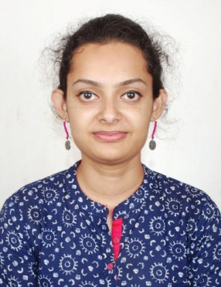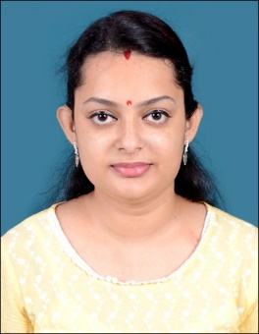**Curriculum Vitae**

**Archita Chakraborti**

[archita.sumi@gmail.com](mailto:archita.sumi@gmail.com)

6289588900, 9836312537

**OBJECTIVES**

Looking for promising challenges on a responsible position which will utilize my skills, flair for introducing work culture in terms of creativity, innovative ideas, with a company offering recognition to quality of work and good career growth.

**PERSONAL INFORMATION**

|  |  |
| --- | --- |
| **Husband’s Name:** | Mr. Riju Chakravorti |
| **Birth Date:** | 25-02-1991 |
| **Gender:** | Female |
| **Marital Status:** | Married |
| **Nationality:** | Indian |
| **Languages Known:** | English, Hindi, Bengali |
| **Permanent Address:** | C/12/1A, Ramkrishna Upanibesh, Sulekha More, Jadavpur, Kolkata  700 092 |

**EDUCATIONAL INFORMATION**

|  |  |  |  |  |
| --- | --- | --- | --- | --- |
| **SN.** | **QUALIFICATIONS** | **BOARD/UNIVERSITY** | **YEAR** | **PERCENTAGE** |
| 1. | Madhyamik | W.B.B.S.E. | 2007 | 63 % |
| 2. | Higher Secondary (10+2) | W.B.C.HS.E. | 2009 | 64 % |
| 3. | Bachelor of Arts (1+1+1) | BURDWAN UNIVERSITY | 2012 | 49.45 % |

**Computer Skills:**

1. CITA, DITA.
2. Knowledge in MS Word, MS Office, MS Power Point, MS Excel & Internet options.

**Extra Curricular Activities:**

1. Passed D.EL.ED. Course (2020-2022) in regular mode 1st division with Distinction.
2. M.A (Nritya Ratna) in “Rabindra Nritya” from S.B.S.O.P.
3. Hooghly Dist. 1st Runners up in ‘Long Jump’ in 2001.

**WORKING EXPERIENCE:**

1. Working as a Class Teacher of – II at “**Darwin International School**” from 07-April-2023 to 30-March-2024.
2. Working as a Back Office Executive in “**Tri Network**” from February 2023.
3. Worked as a Back Office Executive at “**Satyam Road Carriers LLP”** from November 2021 till 31st January 2022.
4. Worked as a CCE in “**Professional Courier**” from May 2018 to till March 2020.
5. Worked as a Teacher in “**Sweet Home-Era**” in Bhadreshwar, Hooghly from August 2015 to till May 2018. And From 06.07.2020 - 12.12.2020.
6. Worked as a “**Dance Teacher**” In **K.V (Kendriya Vidyalaya) Bandel**, in the year 2017.
7. In attached a Pvt. Dance School.

**DECLARATION**

I do here by declare that all the above-mentioned information provided is absolutely true to the best of my knowledge and belief**.**

Thanking you.

With Regards,

Place: Jadavpur, Kolkata

Date:

**ARCHITA CHAKRABORTI**