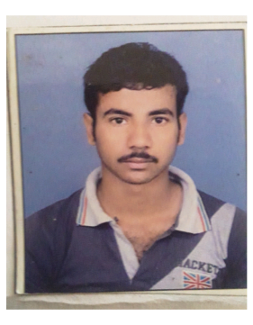 ***BIO – DATA***

**NAME : ARUP SANPUI**

**DATE OF BIRTH : 22.07.1995**

**FATHER S NAME : DAMODAR SANPUI**

**RESIDENTIAL ADDRESS : VILL – CHAKRAIPUR.**

**P.O – YEARPUR. P.S : USTHI.**

**DIST – SOUTH 24 PARGANAS.**

**PIN – 743513.**

**CONTACT NO : 91+ 7076852014**

**NATIONALITY : INDIAN**

**RELIGION : HINDU**

**MERITAL STATUS : MARRIED**

**GENDER : MALE**

|  |  |  |  |
| --- | --- | --- | --- |
| **ACADEMIC QUALIFICATION** | | | |
| **NAME OF**  **EXAMINATION** | **BOARD /**  **UNIVERSITY** | **YEAR OF**  **PASSING** | **PERCENTAGE** |
| **MADHYAMIK** | **W.B.B.S.E.** | **2012** | **47%** |
| **H.S (ARTS )** | **W.B.C.H.S.E.** | **2014** | **53.6%** |

**TECHNICAL QUALIFICATION**

* **DIPLOMA IN ELECTRICAL SERVIEING & REPAIR (ONE YEAR ).**
* **REFRIGERATOR & AIR CONDITIONER (ONE YEAR ).**
* **CCTV INSTALLTION (THREE YEARS)**

**OTHER QUALIFICATION**

* **COMPUTER KNOWLEDGE :**

**[COMPUTER FUNDAMENTAL , MS – WORD , MS –EXCEL , INTERNET , E-MAIL.**

* **CERTIFICATE IN DESKTOP PUBLISHING ( CDTP ).**
* **COMPUTER HARDWARE & NETWORKING ,PRINTER RELATED**

**WORK EXPERIENCE**

* **Working with Bhawanipur College as technical assistant from 1st January 2022.**

**DECLARATION**

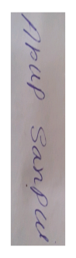 **I hereby declare that all the above information are true according my knowledge.**

**Date :-**

**Place :-**

**Signature of the applicant**